**JWST MAGIC: User’s Guide**

**The Multi-Application Guiding Interface for Commissioning**

October 2018

POC: Lauren Chambers ([lchambers@stsci.edu)](mailto:lchambers@stsci.edu)) or Keira Brooks (kbrooks@stsci.edu)

*Special notes for users:*

* If something is not working as is stated in this guide, please submit an issue on <https://grit.stsci.edu/wfsc/tools> (accessible from WFSC Guiding console – make sure you log in as yourself using your AD username and password) using the “Issues” button on the left-hand side of the page. Please specify that it is for this tool and be specific about the problem that you ran into.
* If the issue you are having is preventing you from completing your task, immediately contact Keira Brooks ([kbrooks@stsci.edu](mailto:kbrooks@stsci.edu), x6821) or Lauren Chambers ([lchambers@stsci.edu](mailto:lchambers@stsci.edu), x6517).

______________________________________________________________________________

**Table of Contents**

1. Setting Up
2. Getting the Input NIRCam Image from the DAN Server
3. Selecting Guide & Reference Stars for an Input NIRCam Image
4. Opening DHAS
5. Testing Selections in DHAS
6. Contingency: Re-selecting Stars and Re-running DHAS
7. Writing the Segment Guiding Override File

**Appendices**

1. Getting the JWST MAGIC Package on your Machine
2. Using APT to Get Guide Star RA & Dec
3. Mirror State Procedures
4. **Setting Up**
5. If you have not yet installed the tools, go to Part VIII, “Getting the JWST MAGIC Package on your Machine”
6. Check that you are in your astroconda environment.
7. Make sure that you have the most up-to-date version of the tools (pull the most recent version of the tools from the repo):

$ cd /Users/<username>/tools

$ git pull origin master

1. **Getting the Input Image from the DAN Server (from SOGS only)**

Note: If you are on your own machine and not in SOGS, and/or not using this for a commissioning rehearsal, you can grab any FGS image or a NIRCam image that was taken with the CLEAR filter (a WL filter will crash MAGIC)

1. To get the input image, navigate in a Terminal window to where you want the files saved and type the following

$ cd /data/jwst/wss/guiding/data

$ ls

1. Confirm with WSS Optics Sim in the front room (preferably over voice loop) that the files in this location are the correct files for this commissioning activity.
2. If all of the files are correct, copy all of the images to the directory that will be used for this activity as established during the setup of the system.

To determine which directory to use, check the [WFSC Guiding Directories Innerspace page](https://innerspace.stsci.edu/display/INSTEL/WFSC+Guiding+Directories).

$ cp * /data/jwst/wss/guiding/{activity_directory}

If there are multiple files, you want to choose the file where the image has the PSFs in the mirror state configuration that you are expecting. This is usually the most recent image, but you can check this by looking at the file names. If you still aren’t sure, check with WSS or WF Ops.

1. **Selecting Guide & Reference Stars for an Input Image**
2. Once you are in the astroconda environment, start an IPython session and launch the main GUI:

$ ipython

In [1]: import jwst_magic

In [2]: jwst_magic.run_tool_GUI()

The main GUI should appear:

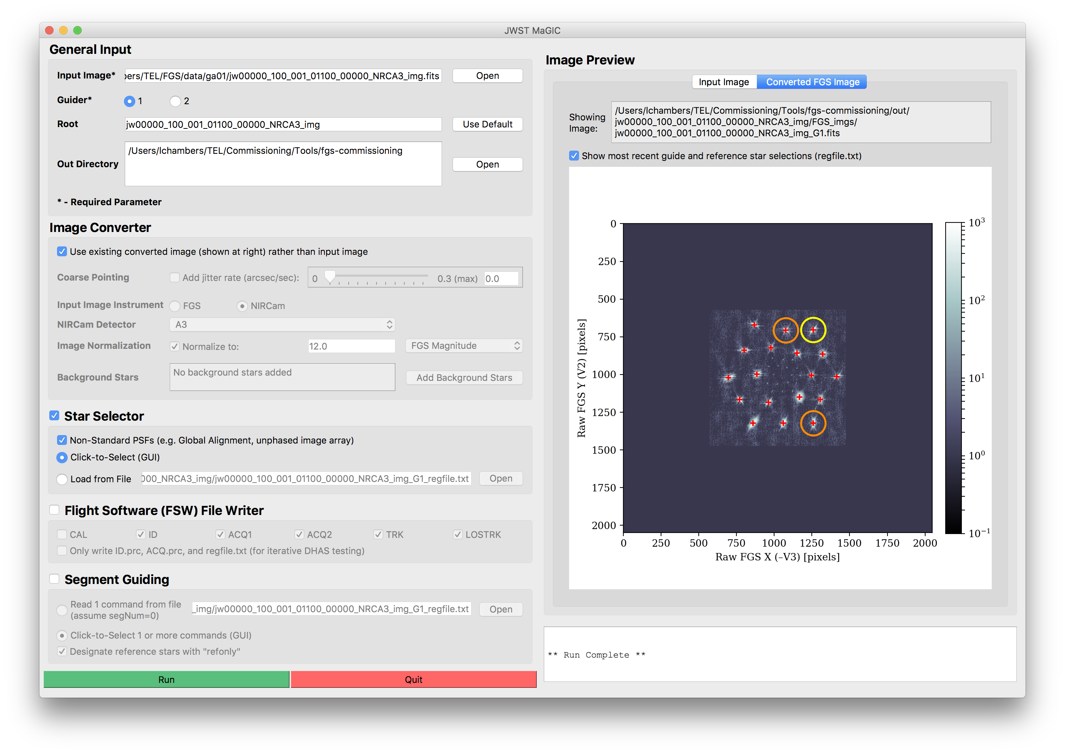

Figure 1 - Main GUI for the JWST MAGIC Tool

1. Set general input parameters:



**D**

**C**

**B**

**A**

Figure 2 - General Input section of the Main GUI

* 1. **Load the input image** **A**  This image will be located in the directory where you copied the files in Part II. A preview of the image and the full path to the image will appear in the Image Preview box at right.
  2. **Specify the guider** **B**  This is the guider that the final image should simulate. If this is not known, check the APT file (see Appendix B for more information about using APT).
  3. **Specify a root name** **C**  If different than the default name that was created when the input image was uploaded. The root will be used to to create the output directory where all created files will reside, out/{root}.
  4. **Change the out directory** **D**  Choose the location to where the files were copied in Part II. An out/ directory will be created in this location, and this is where all the files will be saved.

Considering these parameters all together, the output files will be saved in the {out}/out/{root}/ directory, with names of the format {root}_G{guider}....

1. Set image conversion parameters: (Note: The steps labelled “optional” below will create higher-fidelity simulations, but are not necessary when using MAGIC to generate FSW input or segment override files.)



**E**

**D**

**C**

**A**

**B**

Figure 3 - Image Converter section of the Main GUI

* 1. (Optional) **Simulate the effects of coarse pointing** **A**  by specifying the jitter rate of the observatory. A jitter rate of 0.7 arcsec/sec creates images that are similar to ITM simulations in coarse point. Otherwise, ensure the “Add jitter rate” box is unchecked.
  2. Check that the **instrument** **B** **and NIRCam detector** **C** used to take the input image are set to the correct values; change them if not. (If the NIRCam detector is not defined, the tool will attempt to parse it from the input FITS header.) The FGS-formatted image will be saved to out/{root}/FGS_imgs/{input_image}_G{guider}.fits
  3. (Optional) You can specify the **magnitude or counts for the normalization** **D** of the final image. Otherwise, ensure the “Normalize to” box is unchecked.
  4. (Optional) **Add background stars** to the final image.
     1. Click “Add Background Stars”. **E** The background stars dialog box will appear:



**C**

**B**

**A**

Figure 4 - Background stars dialog window

* + 1. Select which method you wish to use to add stars to the image: randomly, with a user-defined table, or with a Guide Star Catalog (GSC) 2.4.1 query.
       1. To add stars randomly:
          1. Select the **“Add Stars Randomly”** **A** checkbox.
          2. Input the number of stars you want to add to the image
          3. Specify the magnitude range that these additional stars will lie between (relative to the magnitude of the guide star)
       2. To add stars individually:
          1. Select the **“Define Stars to Add”** **B** checkbox.
          2. If you wish to load star locations and brightness from a file, indicate the location of that file.
          3. Otherwise, enter into the table the X position in pixels, the Y position in pixels, and the countrate in J Magnitude of each star you wish to add. Click the “Add Another Star” button to add another row to the table, or the “Delete Star” button to remove a row.
       3. To add stars using a web query from the Guide Star Catalog:
          1. Select the **“Query Stars from Guide Star Catalog 2.4.1”** **C** checkbox.
          2. Enter the RA and Dec of the guide star, being sure to specify if the RA units as either hours or degrees.
          3. Enter the position angle (roll angle) of the observatory.
          4. Click the “Query GSC” button to add the stars that are visible in the FOV of the selected guider.
    2. Click “Done” to save and apply these selections, or click “Cancel” to close the window without updating the background star selections.
    3. Verify that the indicator shows that thcorrect number of background stars have been added.

1. Set star selection parameters:



**B**

**A**

Figure 5 - Star Selection section of the Main GUI

* 1. Ensure the “Star Selector” box is checked.
  2. Inspect the input image and **indicate if the PSFs are non-standard**. **A**  This flag alters the PSF-finding algorithm in the star selector tool to widen the smoothing filter for diffuse images in early commissioning stages when the telescope is unphased. If you are unsure if the PSFs are phased, consult the “Guiding Method” row in the [Guider Commissioning Summary Table](https://innerspace.stsci.edu/pages/viewpage.action?spaceKey=INSTEL&title=Guider+Commissioning+Summary+Table) on Innerspace.
  3. If desired, **load pre-selected guide and reference stars from a file** **B**  by selecting the “Load from File” option and selecting the desired input file. This file must include X/Y pixel coordinates and count rates in the form of a filepath to a regfile.txt or .incat file. Providing this will bypass using the Star Selection GUI to click-to-select the guide and reference stars.

1. Set file writer parameters:

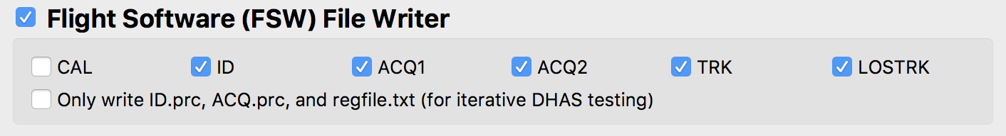

Figure 6 - Flight Software file writer section for the Main GUI

1. Ensure the “Flight Software (FSW) File Writer” box is checked.
2. Check that all of the **necessary FGS steps** are selected.
   1. For general guiding, this includes all of the operational steps: ID, ACQ, and TRK. (These are the default selections.)
   2. For calibration observations, add the CAL step.
3. Run the tool



1. Monitor the terminal window from which you launched the GUI to notice any possible errors that are raised.

*Note:* The output that appears in the command line is also written to:

/data/jwst/wss/guiding/MAGIC_logs/

1. When the Star Selection GUI appears:

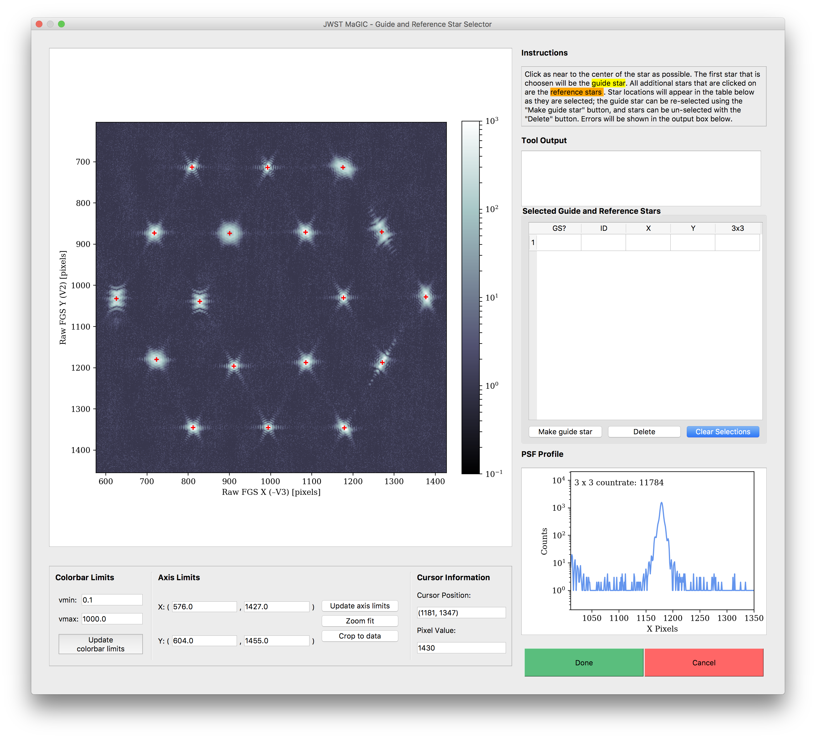

**C**

**B**

**A**

Figure 7 - Star Selection GUI window

* 1. Inspect the PSFs in the image by moving your cursor over different PSFs. Examine the profile plot to see the distribution of light.
  2. Select, by clicking, which PSFs will be the guide star and the reference stars. The first star selected will be the guide star, while any subsequent stars will be reference stars.

*See* *Appendix C* *to choose the guide and reference stars based on the mirror state.*

* 1. If you want to change your selections while in the tool, use the **“Make Guide Star”** **A**  button to change the guide star, use the **“Delete”** button **B**  to remove individual selections, and use the **“Clear Selections”** button **C**  to start over.
  2. When you are happy with your selections, click “Done”

The output files will be located in the specified out directory (look back at the WF Guiding Shift Set Up and Break Down for a reminder of this location).

1. **Testing Selections in DHAS**

*Note:* Don’t close the MAGIC GUI while you are working in DHAS; you will need to use that open MAGIC window later.



Figure 8: DHAS GUI

1. Load the IDstrips.fits file you just created:
   1. Click the blue “Load Multiple .FITS Files” button



* 1. Using the “Current Directory” drop-down menu (or by typing the path directly into the textbox), navigate to the out/{root} directory where the images have been saved
  2. Go the “dhas” subdirectory
  3. Check the “Show All Files” box
  4. Select the IDstrips.FITS file (In the above example, GA_obs1_WFR_G1_IDstrips.fits)
  5. Click “Add →”
  6. Click “Done”

1. Add the Bad Pixel Map
   1. Check the “Apply Bad Pixel Map?” box above the “Load Multiple .FITS Files” button (see figure above)
   2. In the finder window that opens, choose the most recent bad pixel map (check the “rev” number on files with a .pix extention). For DHAS verson 3.0, this file is G1_F11_CV3_Rev_63.pix for guider 1 and G2_F14_CV3_Rev_63.pix for guider 2.
   3. Click “Open”
   4. In the “Image Size Mismatch…” dialog box, click “OK” (the default settings are correct).
2. Run the ID simulator. (DHAS can also be used to simulate ACQ and TRK, but for brevity’s sake we will just check that ID is successful.)
   1. Click the corresponding G1 or G2 button depending on if this is a guider 1 vs. guider 2 image at the top of the page



* 1. Click the small pink “ID-sim” button at the top of the page



* 1. A finder window will appear with the expectation that the user will choose the appropriate .prc file (no text indicates this). For this step (ID) open the ID.prc file corresponding to the IDstrips.fits file that you selected (in the above example, GA_obs1_WFR_G1_ID.prc)
  2. When the star_catalog_page dialog box appears:
     1. Set the Row and Column values to be 12 and 0 (in the bottom left corner of the window), respectively (the X-Angle and Y-Angle values will automatically change to reflect this):



* + 1. If you want to alter your guide & reference star selections, do so here by toggling the “GS” (guide star) and “RS” (reference star) buttons
    2. Click the “Done” button.
  1. When the ID Mode Setup dialog box appears, click “OK.”

1. Wait for the simulator to run
2. When the finder window pops up, press “Cancel”
3. DHAS results: Commanded (CMD) reference stars are denoted by yellow triangles (∆). The commanded (CMD) guide star is denoted by a yellow cross/plus sign (+). The reference stars that the DHAS has found are denoted by blue x’s (x) and the guide star is denoted by a blue asterisk (*). See the screen shot below for an example of a successful DHAS run.



Figure 9: Example of a successful DHAS run

1. Inspect the DHAS results
   1. Do the stars that DHAS found (in blue) match the stars you commanded it to find (in yellow) If not, DHAS has **failed**.
   2. For more detailed DHAS diagnosis:
      1. Does DHAS think it successfully found the guide star? (Does “Status” equal SUCCESS?)
      2. Did DHAS find all of the stars? (Does “# Candidates” equal 18 – for GA or image array steps?)
      3. If necessary, click the “Export” button to more closely examine DHAS’s output plot and/or save the image as a .PNG
2. If all goes well, click the “EXIT” button in the DHAS GUI to exit the GUI and then type “exit” into the Command Window to close MATLAB

**If DHAS fails, we need to try a different orientation of guide and reference stars until we find a successful one. See Part VI.**

If DHAS is successful, move on to Part VII.

1. **Contingency: Re-selecting stars and Re-running DHAS**

When re-selecting stars for testing in the DHAS, not all of the files generated by the commissioning tools need to be rewritten; only the files that specify which segments are the guide star and reference stars need to be changed (namely, the ID.prc and regfile.txt files). Thus, though completely re-running the tool would work to re-select the guide and reference star segments (see Part III), it is not necessary. We have developed a faster method for re-selection and file rewriting, detailed here.

1. In the main GUI, select the “Only write…” button within the Flight Software File Writer box. All other options in the interface will be disabled.

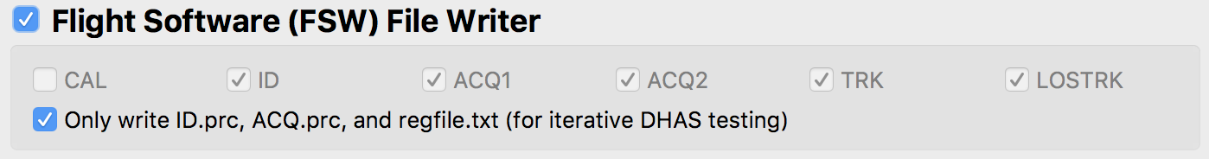

Figure 10 - Flight Software file writer section of the Main GUI for the case when only the .prc files are over written

1. Run the tool:



1. When the Star Selection GUI appears, again examine your input image.

*Note:* If you prefer to analyze the image in DS9, you can do so by typing $ ds9 name_of_image.fits into the command line or !ds9 name_of_image.fits in IPython. Be sure to load the image in the …/FGS_imgs/ directory, which is your FGS image. Since DS9 displays images differently than Python, go to the Zoom menu in the menu bar of DS9 and select “Invert Y”.

1. Select new guide/reference stars and click “Done”.

*See* *Appendix C* *to choose the guide and reference star based on the mirror state.*

This step will overwrite the existing ID.prc and regfile.txt files with the new star commands.

1. Re-run DHAS (Part V)

**If DHAS fails again, we still need to try a different orientation of guide and reference stars until we find a successful one. Repeat** **Part VI****.**

If DHAS is successful, move on to Part VII.

1. **Writing the Segment Guiding Override File**
2. In the main GUI, select the “Segment Guiding” box. All other options in the interface will be disabled.

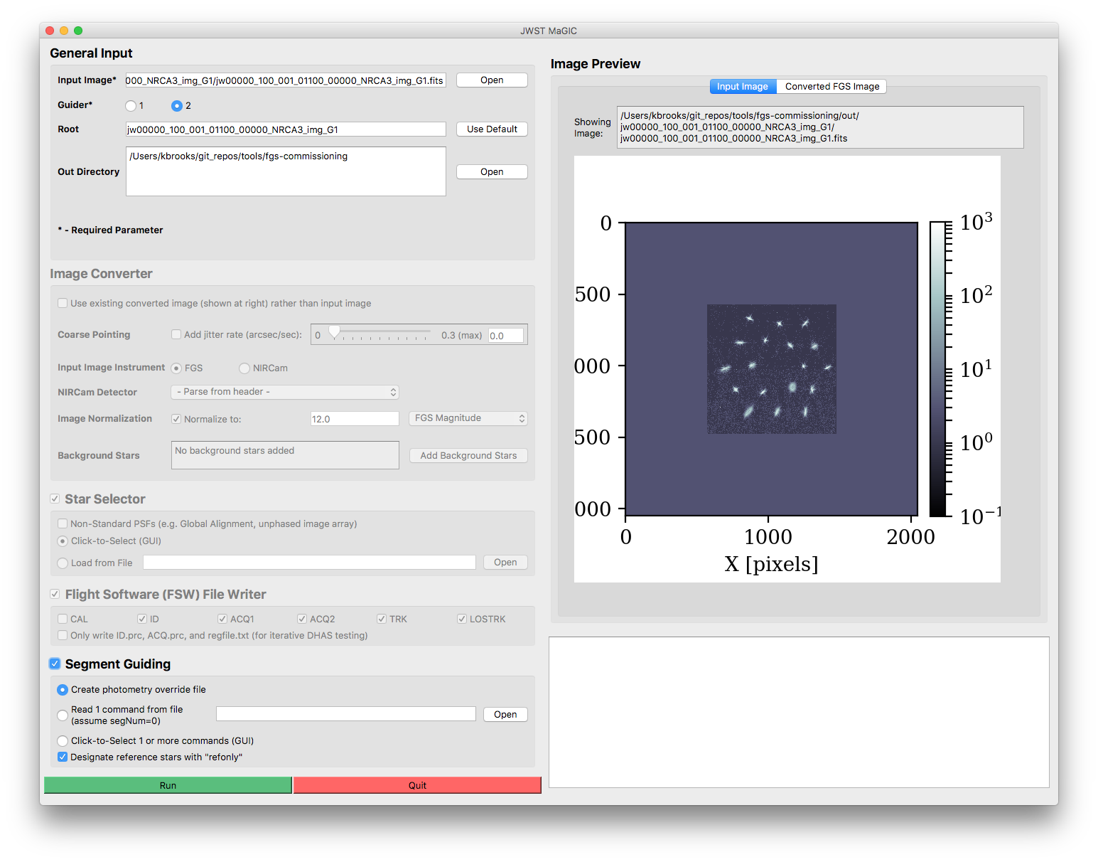

**D**

**C**

**B**

**A**

Figure 11 - Segment Guiding Section of the Main GUI

1. Determine whether to generate an override file from an existing file or using the click-to-select GUI:
   1. If creating a photometry override file using the **“Create photometry override file” radio button A**  , see section VII. below.
   2. If creating an override file for a visit where the mirrors are in an array and you wish to use the same guide and reference stars from Part III, select the **“Read 1 command from file” radio button** **B**  and don’t change the auto-populated segment guiding filepath. This creates the segment override file so that it only uses the guide and reference star selected by the user in step III and will bypass the override file creation using the Segment Guiding GUI. If this file is provided, skip to step 6 below.
   3. If creating an override file for a visit where the mirrors are in an array and you wish to use different guide and reference stars from Part III that are specified in a different file (most likely a regfile.txt or a .incat file), select the **“Read 1 command from file” radio button** **B**  and specify the path to this file. Providing this file will create the segment override file so that it only uses the guide and reference star selected by the user in step III and will bypass the override file creation using the Segment Guiding GUI. If this file is provided, skip to step 6 below.
   4. Otherwise, select the **“Click-to-Select 1 or more commands (GUI)” radio button** **C**  to launch the GUI that will allow you to click-to-select multiple orientations of guide and reference stars.
2. Designate whether to mark reference stars in the segment guiding override file with the **“refonly” check box**. **D**  Unless something has broken in VSS, this should be checked.
3. 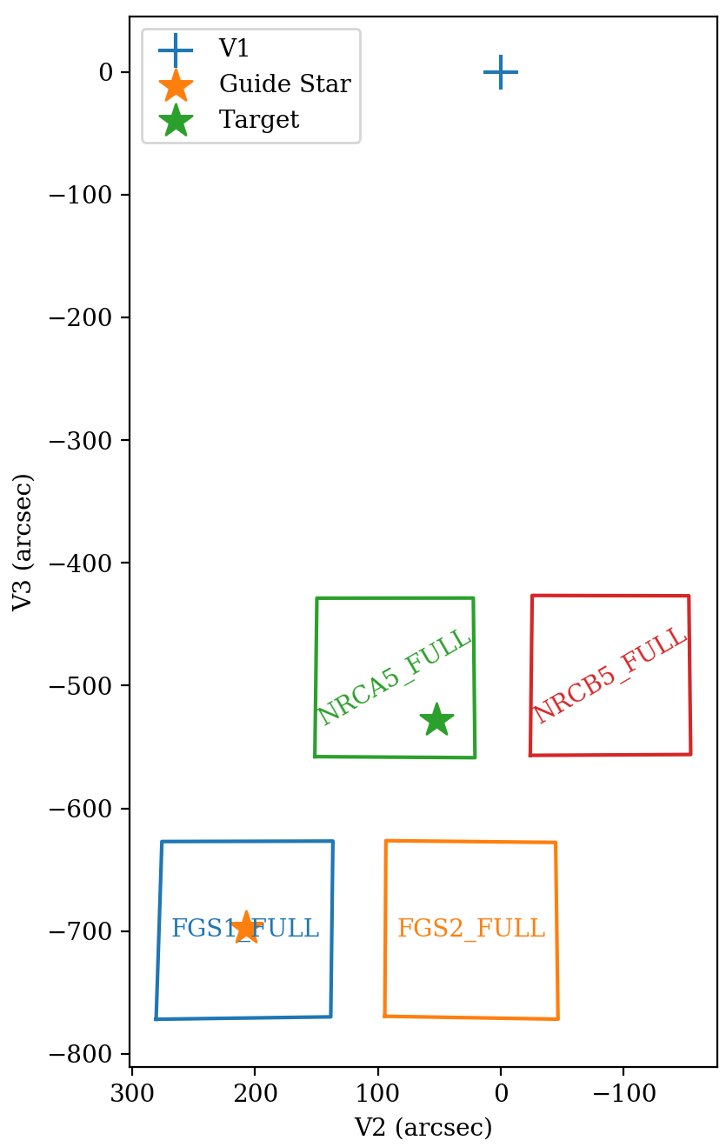Before running the tool, obtain the following parameters with the following methods:
   1. **APT parameters**: If you do not know, ask the Wavefront Ops for the program ID, observation number, and the visit number.
   2. Guide star **RA** & **Dec**: Retrieve the guide star ID from the APT file (see Appendix B for a step-by-step guide for doing this). Go to the Guide Star Catalog webform ([http://gsss.stsci.edu/webservices/GSC2/  
      WebForm.aspx](http://gsss.stsci.edu/webservices/GSC2/WebForm.aspx)), and query with the guide star ID in the “HST ID” field to determine the RA and Dec.
   3. **Position Angle**: Ask the S&OC for the visit position angle at the guide star (V3PA@GS).

*See the figure at right to clarify the difference between V1, the target, and the guide star.*

* 1. Get the current **V2 & V3 boresight offset** from the Wavefront Ops.

1. Run the tool:



Figure 12 – Locations of V1, the guide star, and the target.

1. 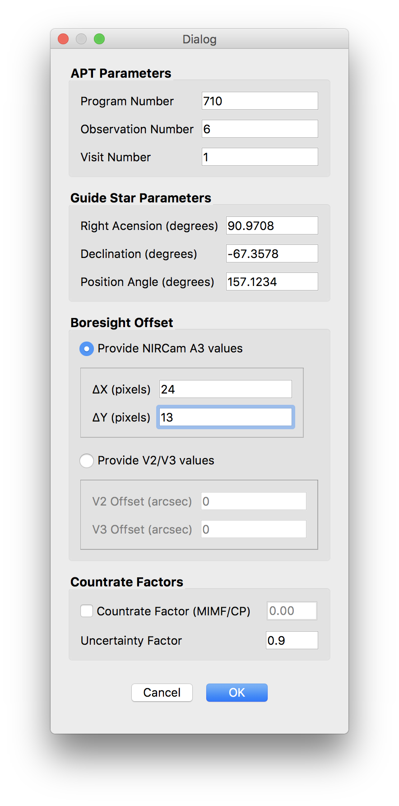When the Segment Guiding Dialog Box appears (shown at right), define the segment guiding parameters, including:
   1. **Program Number** – ID of the current APT program; three to five digits
   2. **Observation Number**
   3. **Visit Number**
   4. **Right Ascension** *(optional)* of the guide star
   5. **Declination** *(optional)* of the guide star
   6. **Position Angle** of the observatory at the guide star at the time of the visit
   7. **V2 Boresight offset** *(optional)*
   8. **V3 boresight offset** *(optional)*
   9. **Countrate factor** *(optional)* – a factor between 0 and 1 that all segment magnitudes are multiplied by in the segment override file. Used for cases such as MIMF and CP when the segments are stacked but unphased, and so the brightness of the guide star is dimmed.

*See* *Appendix C* *for information about the countrate factor based on the mirror state.*

* 1. **Uncertainty factor** *(optional)* – the degree of uncertainty in the countrate of each segment. e.g., an uncertainty factor of 0.9 for a star with a countrate of 1,000 writes an uncertainty of 900.

Figure 13 - Segment Guiding Dialog Box

1. Click “OK” to continue.

When the Segment Guiding GUI appears:

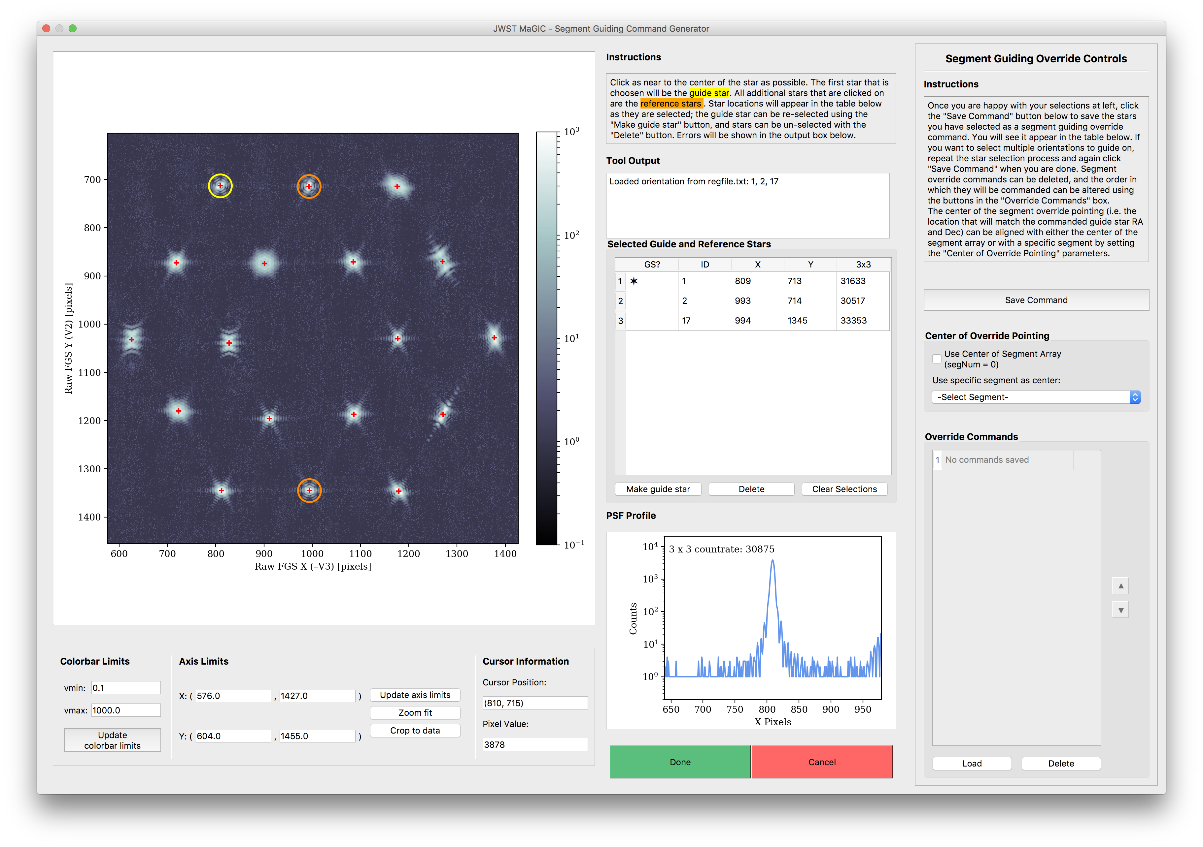

**F**

**E**

**D**

**A**

**B**

**C**

Figure 14 - Segment Guiding GUI Window

1. Repeat the steps outlined in Part III to select the guide and reference stars – the ones that you verified were successful with DHAS – for one segment guiding override command.
2. When you are happy with your selections, click the **“Save Command” button**. **A**  You will see the IDs of the stars you selected appear in the **“Override Commands”** table **C** .
3. To add another command, again repeat the steps outlined in Part III to select guide and reference stars, and again click the **“Save Command” button**. **A**  d
4. To change the order of the commands, use the **up and down arrow buttons**. **D**  To view a saved command on the plot, click the **“Load” button**. **E**  To remove a command from the list, click the **“Delete” button**. **A**  d
5. Select the **center of override pointing**. **B**  This sets the origin of the ideal frame (i.e. the location of the guide star if the segments were stacked). It can either be set as the center of the segment array, using the “Use Center of Segment Array” checkbox, or the location of a specific segment using the dropdown box.

*See* *Appendix C* *for more about selecting the center of override pointing based on the mirror state.*

1. **Writing the Photometry Override File**

In the case of MIMF where we only need to change the photometry of the guide star (the RA and Dec and expected count rates are taken from the APT file), we need to make an override for Planning & Scheduling but this is for the photometry and will have no information about the segments (because the PSFs from the individual segments are stacked).

Creating a photometry override file through MAGIC:

* + - 1. 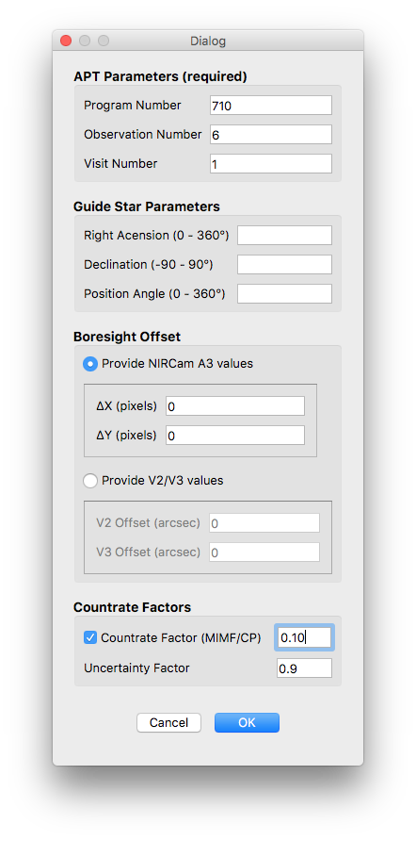Load the file for this observation, select the guider, the set the out directory and root.
      2. As in section VI, in the main GUI, select the “Segment Guiding” box. All other options in the interface will be disabled. Note: You do not need to run the other parts of MAGIC when creating a photometry override file.
      3. Select the **“Create photometry override file” radio button** ( **A** in figure 11 above)
      4. Run the tool.
      5. When the Segment Guiding Dialog box opens, fill in the Program ID, Observation Number, and Visit Number just as you would for creating a segment override file.
      6. Do not fill out any of the guide star parameters as this information is the same as what is available in the APT file and does not need to be overwritten.
      7. Check the Countrate Factor box and add the factor that is expected for this observation. This number needs to be between 0 and 1.
      8. Click “OK”

## Creating a photometry override file in IPython:

Alternatively, in the case of having to create multiple photometery override files, this can be done in IPython with a for loop.

* **root** – This is the root that will be used for the observation. This has to do with where files are saved so consistency is important
* **program_id** – ID of the current APT program; three to five digits
* **observation_num** – the observation number for this observation
* **visit_num** – the visit number for this visit
* **click_to_select_GUI** –since we are not selected guide and reference stars, set this flag to False
* **parameter_dialog** – since we are bypassing the segment guiding dialog box above, set this flag to False

In [1]: from jwst_magic import segment_guiding

In [2]: root = ‘{root}’

In [3]: program_id = {PPPPP}

In [4]: observation_num = [1, 3, 4, 5, 7]

In [5]: visit_num = [1, 1, 1, 2, 1, 1]

In [6]: for i, (o, v) in enumerate(zip(observation_num, visit_num)):

segment_guiding.segment_guiding.run_tool(root=root,

program_id=program_id,

observation_num=o,

visit_num=v,

click_to_select_GUI=False,

parameter_dialog=False)

**Appendix A: Getting the JWST MAGIC Package on your Machine**

This section is only if you are install MAGIC on your own machine. For SOGS, you will have to follow the [instructions on the JWST ITAR Wiki](https://jwstitarwiki.stsci.edu/pages/viewpage.action?spaceKey=WFSCOWG&title=WF+Guiding%3A+Set+up+personal+SOGS+environment).

1. Activate your astroconda (Python 3)environment. For installing astroconda see: <http://stsci-env.readthedocs.io/en/latest/installing_anaconda.html>
2. $ cd into the directory where you want to keep the package.
3. Clone the tools from the grit repository:

$ git clone git@grit.stsci.edu:wfsc/tools.git

1. Install the jwst_magic package:

$ cd tools/fgs-commissioning

$ pip install -e .

The package installation process will also check for the following package dependencies, and automatically install them using pip if they are not found:

* + - astropy
    - matplotlib
    - numpy
    - photutils
    - PyQt5
    - pysiaf
    - pytest
    - pyyaml
    - requests

**Appendix B: Opening DHAS**

1. If you are working on SOGS and you have not already configured DHAS to work on your personal SOGS account, follow the [instructions on Innerspace](https://innerspace.stsci.edu/display/INSTEL/Setting+up+the+DHAS+on+your+SOGS+account) for setting DHAS up correctly on SOGS.
2. Find the MATLAB icon on the dock and double click to open MATLAB (or press CMD + space to open Spotlight and search for MATLAB)
3. In the MATLAB interface, if not already there, navigate to the DHAS, version 3.0 directory

$ cd /Users/<username>/Documents/MATLAB/dhas/v3.0/fitsdisp2_v3p0/

1. Start the DHAS GUI:

$ fitsdisp2

**Appendix C: Using APT to Get Guide Star RA & Dec**

1. Open APT
2. Load the APT file for the current program:
   1. File > Retreive from STScI > Retreive using Proposal ID…
   2. Enter the proposal number (e.g. 1141 for Global Alignment). If you’re not sure of the number, check out this [table of proposals](http://www.stsci.edu/ops/jwst-pit-status.html).
3. Using the navigation panel at left, navigate to the “Observations” folder, open the desired observation folder, and look at the form editor for the desired observation. The observation forms are the ones that have (Obs #) in their name.
4. Click the “Special Requirements” tab
5. If the observation is a NIRCam observation (“Instrument” is NIRCAM or WFSC):
   1. If there is a special requirement called “Guide Star ID”:
      1. Take note of that ID (e.g. N13I018276)
      2. Query for this guide star using the Guide Star Catalog webform (<http://gsss.stsci.edu/webservices/GSC2/WebForm.aspx)>, inputting that ID as the HST ID
      3. Copy the RA and Dec from the web results
   2. If there is no “Guide Star ID” special requirement and there is a requirement that states “PCS Mode COARSE”, then that observation is taking place in coarse pointing mode and guiding will not be involved. Ask yourself why you are doing this in the first place.
   3. If there is no “Guide Star ID” special requirement and guiding is taking place, it is not possible to get the guide star from this APT file. Talk to Ed Nelan ([nelan@stsci.edu](mailto:nelan@stsci.edu)).
6. If the observation is an FGS observation:
   1. If there is a special requirement called “Fiducial Point Override” that specifies a NIRCam aperture, it is not possible to get the guide star from this APT file. Talk to Ed Nelan ([nelan@stsci.edu](mailto:nelan@stsci.edu)).
   2. Otherwise, take note of the number and name of the target for this observation.
   3. Using the navigation panel at left, navigate to the “Targets” folder, open the “Fixed Targets” folder, and look at the form editor for the selected target.
   4. Copy the RA and Dec of this star

**Appendix C: Mirror State Procedures**

*Modified from Appendix D in the OTE CAR procedures.*

|  |  |  |  |
| --- | --- | --- | --- |
| Mirror State | Guide and Reference Star Selection Criteria | Center of Pointing | Countrate Factor |
| Image Array (large or small) | *Guide Star*:   * Choose the PSF with the most compact shape and sharpest peak.   *Reference Stars*:   * Choose two (2) reference PSFs, preferably on the outer ring of the image array, that are as compact as possible. Be sure that the distances between selected PSFs are unique (a good idea is to choose one star close to the guide star and one that is far away). | The center of the image array | N/A |
| Small Image Array with one PSF kicked out | *Guide Star*:   * Choose the PSF that has been kicked out.   *Reference Stars:*   * Choose two (2) reference PSFs, preferably on the outer ring of the image array, that are as compact as possible. Be sure that the distances between selected PSFs are unique (a good idea is to choose one star close to the guide star and one that is far away). | The center of the image array | N/A |
| Stacked PSFs with one kicked out | *Guide Star:*   * Choose the PSF that has been kicked out.   *Reference Stars:*   * Stacked PSFs | The stacked PSF | N/A |
| Stacked PSFs | *Guide Star*:   * Stacked PSFs   *Reference Stars*:   * None | The stacked PSF | As needed (TBD) |